The main danger for you from flammable and combustible liquids is obvious in their names; fire and explosion. Improper handling and storage of these liquids can lead to dangerous flash fires. These liquids have very specific definitions that allow them to be classified.
- Flammable liquids will ignite easily and because of this, are more dangerous than combustible. This is because they produce enough vapors to ignite below 100°F. Examples include gasoline, acetone, mineral spirits and turpentine.
- Combustible liquids are less dangerous than flammable liquids because they ignite at temperatures above 100°F. Diesel fuel, kerosene, mineral oil and oil-based paints are all combustible liquids.
Because of this subtlety, OSHA deals with these liquids together. They use flammable as their limit because they are more dangerous. These liquids can be very dangerous to you on the jobsite. It’s important to remember the following safe practices while on the job:
- Only use or store flammable liquids inside a building when it is absolutely necessary. If it is necessary to store them inside, a building it should be the minimum amount necessary.
- You should only carry flammable liquids around in safety approved containers.
- It can be a good safety practice for there to be a list of all flammable liquids used at a jobsite and where they’re located.
- NEVER store flammable liquids in a furnace or boiler room or near any potential heat source.
- Gasoline should only be stored in UL Type I or Type II safety cans. This also applies to your gas use at home. You should store no more than 10 gallons at home and it is never to be inside and only transported 1 gallon at a time in an approved safety container.
- Any drum or portable tank that is used to dispense flammable liquids must be properly bonded and you must use grounding techniques.
- Remember to use reduced-spark tools in areas where flammable vapors may be present.
- Flammable liquids should be transported in a safety-approved container that holds 60 gallons or less
.
- If it’s necessary to store more than 25 gallons in one building, a UL listed flammable liquid cabinet should be used. An alternate solution is a separate storage shed at least 30 feet from any main building.

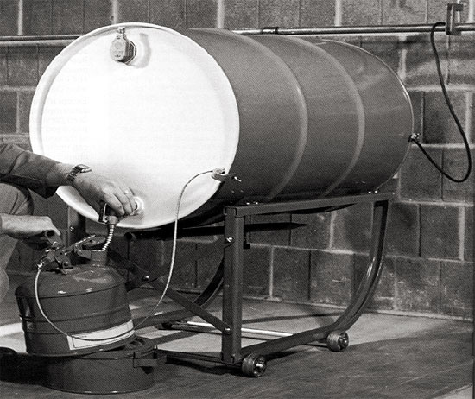
DISCUSSION QUESTIONS
Why are flammable liquids are considered more dangerous than
combustible liquids?
Why should you never store flammable liquids in a furnace or boiler room?

COMPANY: _______________________________________ _____ SAFETY MEETING
JOB/DEPT: ________________________________________ _____ SAFETY TRAINING
DATE: ____/____/_______ TIME: _________
TOPICS ADDRESSED: ______________________________________________________________________________________
EMPLOYEE'S SIGNATURES:
______________________________ ______________________________ ______________________________
______________________________ ______________________________ ______________________________
______________________________ ______________________________ ______________________________
______________________________ ______________________________ ______________________________
______________________________ ______________________________ ______________________________
______________________________ ______________________________ ______________________________
______________________________ ______________________________ ______________________________
EMPLOYEE SUGGESTIONS AND RECOMMENDATIONS: ______________________________________________________
____________________________________________________________________________________________________________
____________________________________________________________________________________________________________
ACTION TAKEN: __________________________________________________________________________________________
____________________________________________________________________________________________________________
____________________________________________________________________________________________________________

_______________________________________________ _____/_____/_____
Supervisor's Signature Date
_______________________________________________ _____/_____/_____
Safety Coordinator's Signature Date

